Xbee S1:

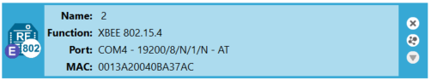

API:

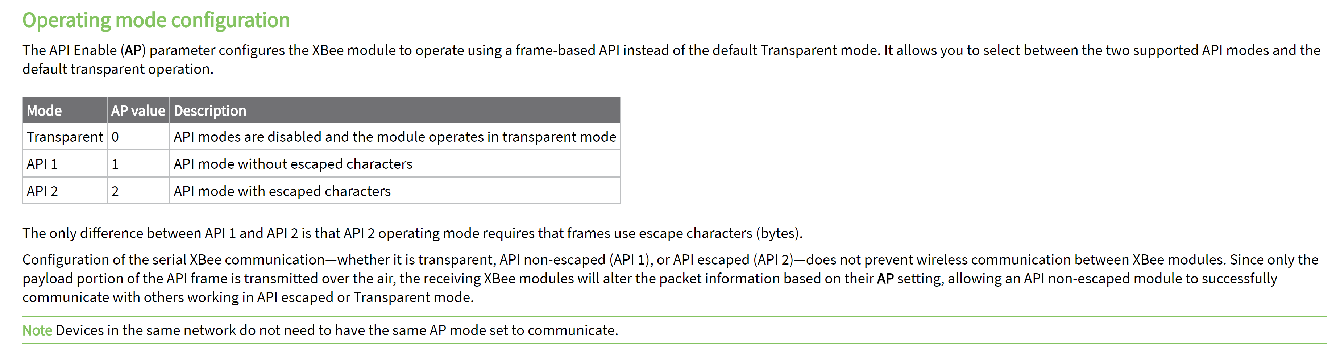

<https://os.mbed.com/cookbook/mbed-application-board>

<https://os.mbed.com/teams/Digi-International-Inc/code/XBeeLib/wiki/Sending-data-to-another-module>

<https://www.digi.com/support/forum/rf-solutions-and-xbee/digimesh-mesh-networking>

<https://www.digi.com/support/forum/47024/network-ack-failure-and-address-not-found-errors>

<https://www.digi.com/support/forum/66116/how-digi-mesh-s1-network-perform-the-routing-mathod>